How to Schedule an Inspection
- Login in.
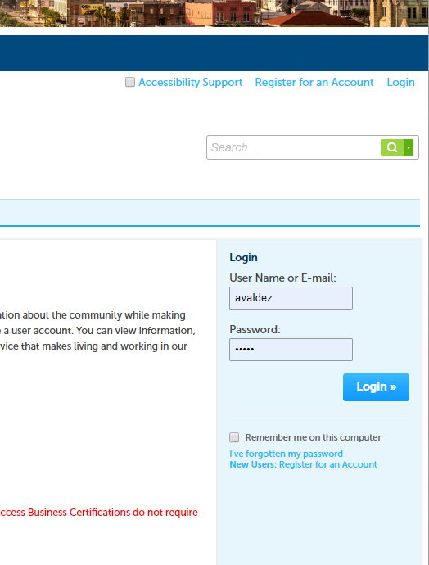
- Click SCHEDULE, then click BUILDING INSPECTION.
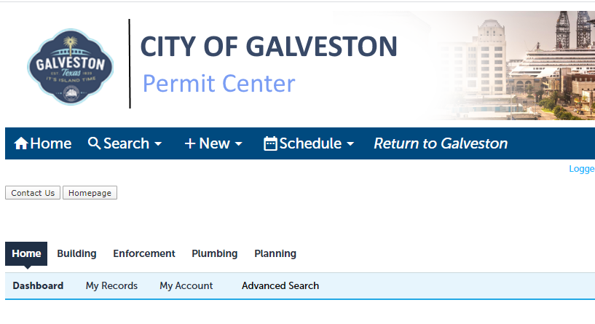

- Scroll down to GENERAL SEARCH.
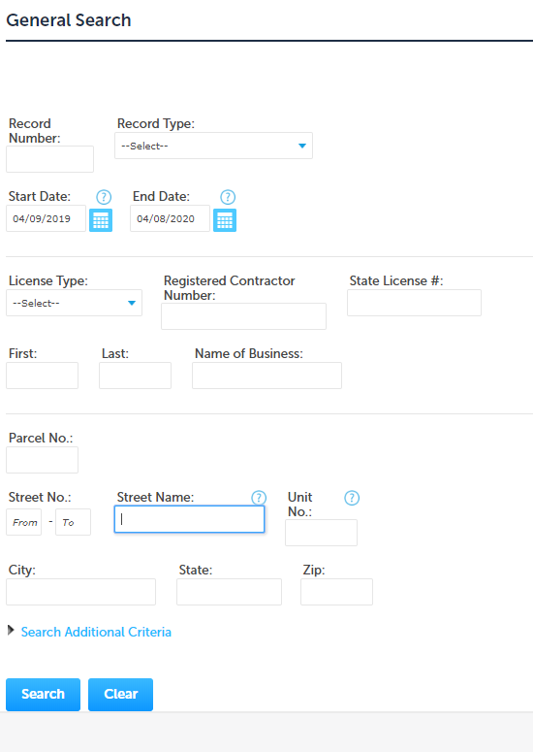
- Search the address, then click SEARCH.
- Click the RECORD NUMBER to schedule the inspection.
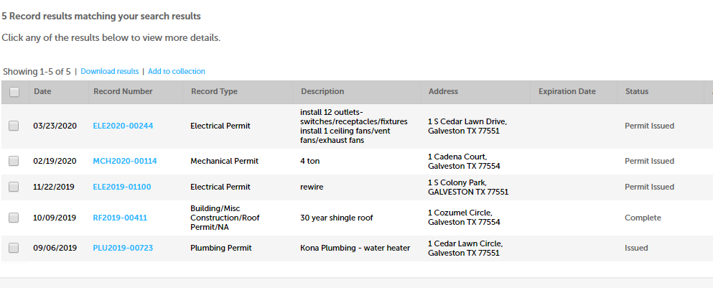

- Click SCHEDULE OR REQUEST AN INSPECTION.
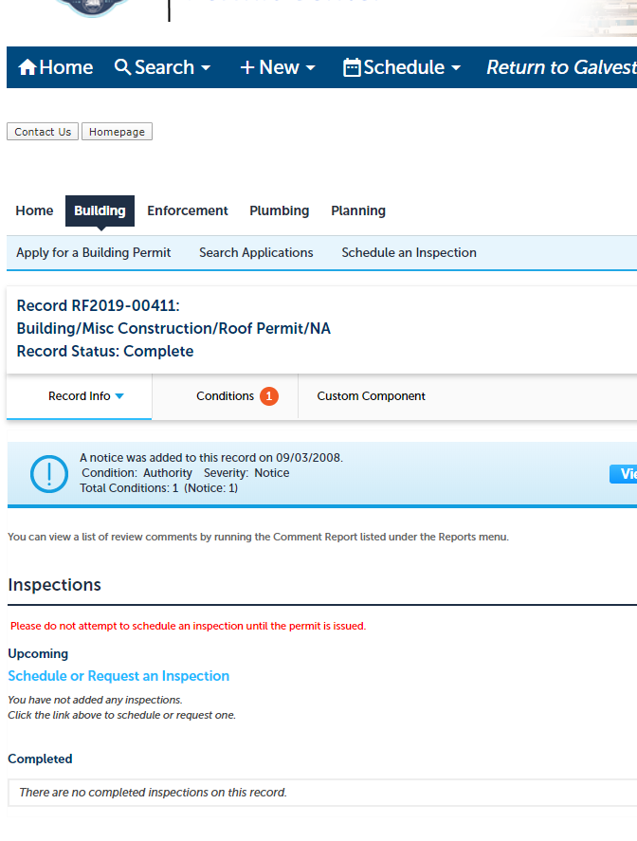
- A pop window will appear, click the inspection.
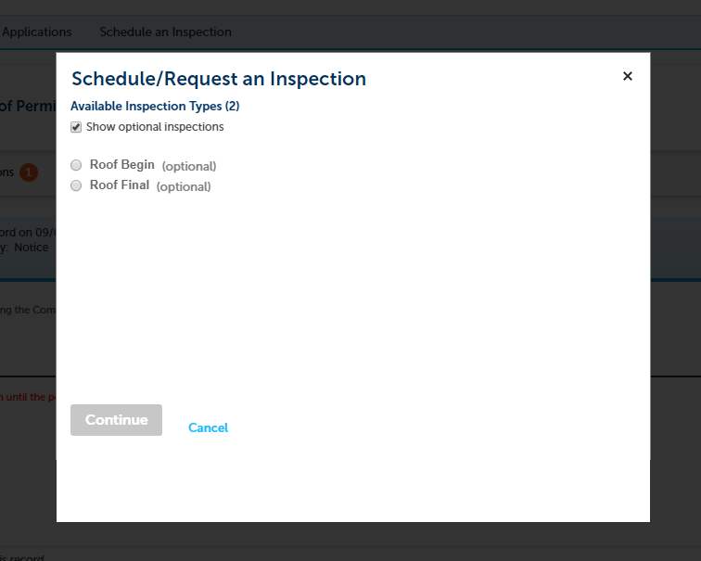
- Click CONTINUE.

- Click the date. Click CONTINUE.
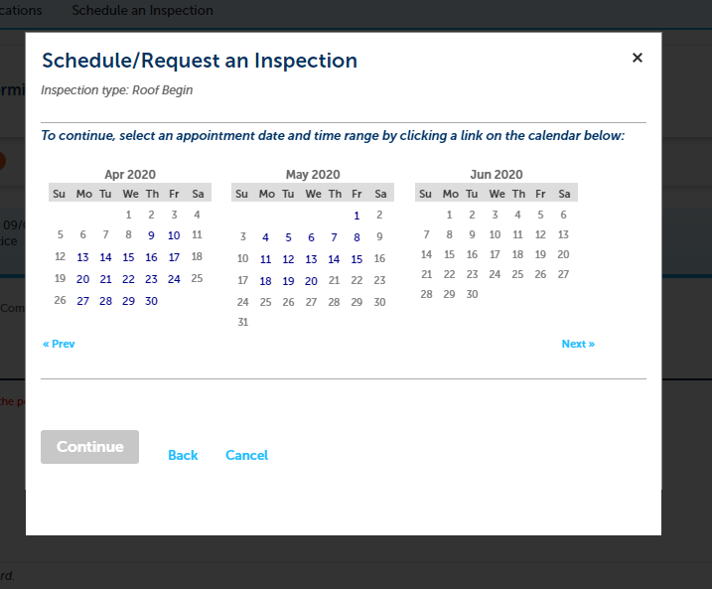
- Click CONTINUE.
- Add additional note if necessary.
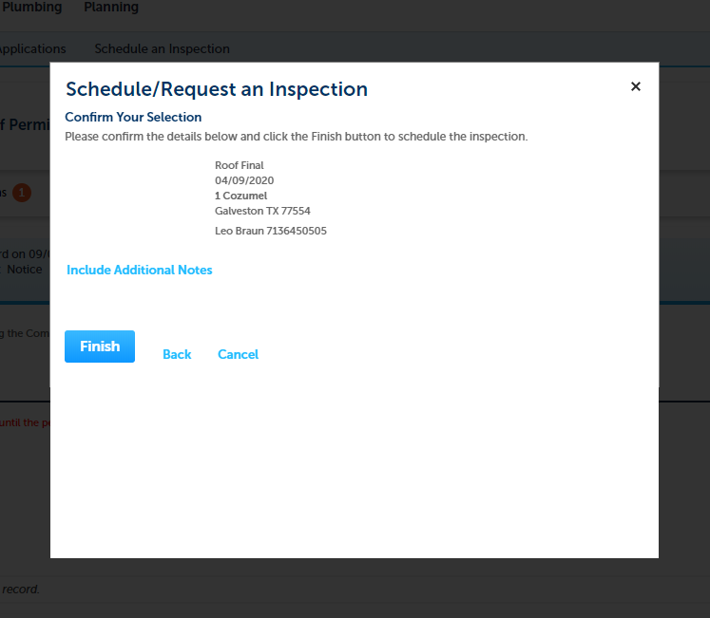
- Click FINISH.

